BCI Expense & Time Management System (BETS)

The BCI Expense & Time Management System is a web-based system designed to facilitate BCI personnel in submission of hours and expenses for approval.
This document describes the process for initial setup and outlines guidelines for use.

- To access the system, users should go to: http://bets.brosna.com/BCI_Home.asp

- This link will take the user to a login screen (see fig.1)

fig.1

- User ID and Personnel Nr. will have been supplied by the BCI Administrator.
- Your Password will initially be setup to be the same as your personnel number.
- After your first login you will be prompted to change your password. (see fig.2)

fig.2

- At any time you can change your password via the link above.
- If you forget your password, you may have it e-mailed to you by entering your User ID and Personnel Nr. and selecting the link on the login screen (fig.1).

Time Reporting

- Timesheets must be completed by close of business on Monday of each week for the previous weeks work (Monday to Sunday). This allows ample time for your Project Manager (PM) to approve or query your submission.
- Delayed entries will inevitably lead to delayed payments so please try to have the timesheets completed on time.
- After login, you will be at the main BETS screen.
- Selecting the “Timesheets” link in the toolbar will bring you to a new screen where you will be able to select a new timesheet and also check your timesheet status going forward. (see fig.3)

Fig.3

- Select “Create New”. A new timesheet will open (see fig.4)
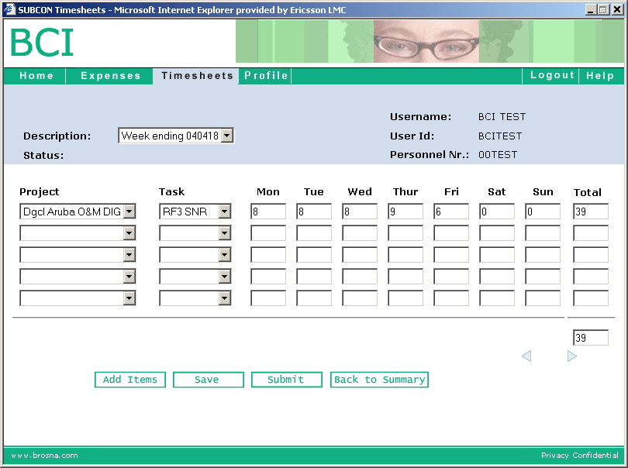

Fig.4

- Select your Project Code from the drop down-menu.
- Select your task code from the drop-down menu (provided by BCI admin.)
- Enter your hours for each day in the spaces provided.
- If you work on more than one project in one week, simply select the second project code, task code and divide your hours accordingly.
- When your entries are complete, press the “Save” button. At this point you can still edit your timesheet if needed.
- If you are ready to submit your timesheet to your PM for approval, press the “Submit” button.
- If the PM has reason to reject your timesheet, you will have to edit then resubmit it.

Expense Reporting

- Expenses should be submitted on the first day of each month.
- Selecting the “Expenses” link in the BCI toolbar will bring you to a new screen where you will be able to select a new expense report and also check your expense report status going forward. (see fig.5)
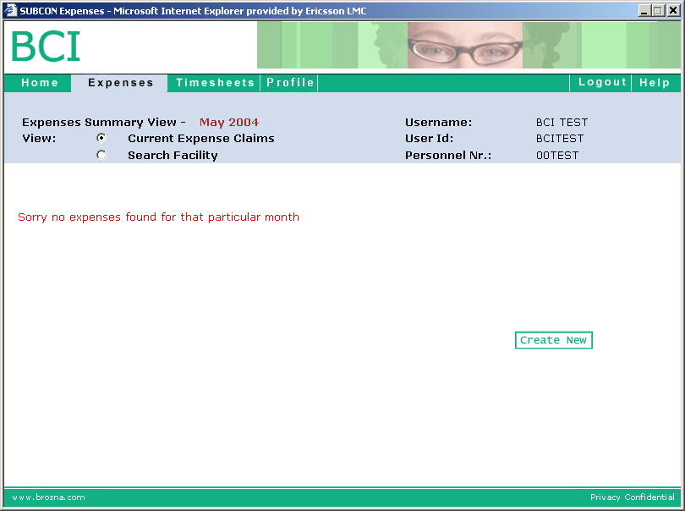

Fig.5

- Select “Create New”. You will be taken to a new screen (see fig.6).

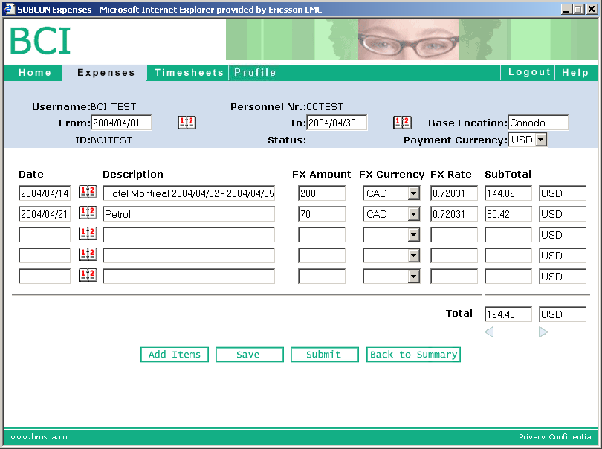

Fig.6

- Use the web-calendar functions to select the first and last day of the month, entering this info into the ‘From’ and ‘To’ boxes respectively.
- Your ‘Base Location’ and ‘Payment Currency’ should be as per your Schedule A of your Contract.
- Individually itemize each claimable expense in the boxes provided on this webpage. For example, in the first line in fig.6, two nights in a hotel in Montreal came to CAD$200. This is claimed by entering the Foreign Exchange amount or ‘FX Amount’ of 200, the ‘FX Currency’ of CAD, and finally the ‘FX Rate’. This is a monthly average obtained from the www.oanda.com website. (Select the link ‘FXHistory’ from the left hand menu, enter the beginning and end of the month, select your currencies, and click on ‘Get Table’). Note that the ‘Subtotal’ values are generated automatically.
- If you need more line-items than are provided on the first screen, select the small arrow (>) icon to open an additional page.
- When your entries are complete, press the “Save” button. At this point you can still edit your expense claim if needed.
- If you are ready to submit your expense claim to your BCI manager for approval, press the “Submit” button.
- If the BCI manager has reason to reject your expense report, you will have to edit then resubmit it.
- Fax each receipt to the following number C/O: BCI Administrator:+1 972 692 6981
- Mail (by ordinary post) or deliver the originals of the receipts C/O: BCI Administrator, 17440 N. Dallas Pkwy, Suite 210, Dallas TX 75287.

Concluding Routines

- When the BCI Administrator is in receipt of the above submitted BETS expense report and timesheets, you will receive an e-mail confirming the total amounts approved. You may verify the details on the BETS system.
- If you are a permanent employee, this will correspond with your automatic payment amount.
- If you are a consultant through another company or management company, this e-mail is what you should provide to your company to raise invoices from.
- It is important to have the expense template and receipts submitted as close to month end as possible in order to meet the cut off time for payments.

Profile

- The other tab on the toolbar is profile. It is important that you maintain your contact information.
- The e-mail in this section is where you will receive your approval confirmation and also your password info if you change it.

