Special Date events preparation for the Bran and other males~
Dancing basics if there will be any:
Video #1: http://www.youtube.com/watch?v=xBkfR_0nDAA
Video #2: http://www.youtube.com/watch?feature=fvwp&v=48LQFzXSad0&NR=1

Make sure the dances fit the theme and music~
Basic checklist:
- Plana way to ask her. Even if she’s your girlfriend, make it fun and special. <3
- Manners, Manners, Manners
- Sense of humble –confidence-, but still an etch of authority
- Plan, plan, plan, plan AHEAD
- Suit and tie essential, this is a special night. Try to match your dats dress if possible, or go for an overall theme.(Make sure you both know what theme it is.)
- HYGEINE is extremely important, you look good, you feel good and the other way around! Take extra time to plan ahead to make sure you get everything done from clipping your nails to brushing your teeth to deodorant and cologne. The ladies are spending all day (Maybe even all week…>w>) probably getting ready for this night. Don’t you dare shortchange them.
- The corsage. (Bran, you did well last time! <3) Many places offer them and the people working there are willing to help, but do not go in without a basic idea of what you want. Make sure the flowers match your theme and colors!
- Otis Redding. Frank Sinatra, Elvis Presley. They all knew something about love in music, Plan the music AHEAD of time! Make sure this music list also goes with your theme and vibe of the night!
- Fancy shoes=fancy socks=fancy suit=fancy tie=fancy cologne=fancy place=fancy music=fancy manners=fancy you. Simple.
- Have a change of clothes ready if you plan on chilling out somewhere after, it needs to be comfy, yet still look decent.
- Classy mints, may your breath always smell good. No gum, too messy and where to put it when you’re done?
- The compliments. “You look nice” or “You look pretty” or “Nice dress” will not cut it. Learn some lovely sayings from the heart. Plan ahead. Here are synonyms for “beautiful”: http://thesaurus.com/browse/beautiful
- And, relax and have fun!!! Being prepared and having a plan will make the night go smoothly and stress-free and help you and your dates enjoy it more!

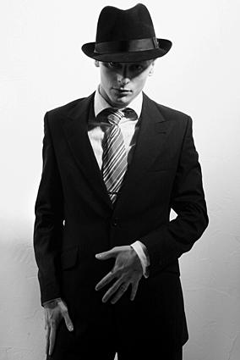
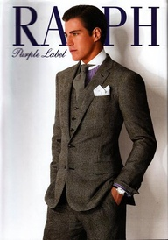
Different themes:
Greys and blacks with darker shades mixed with white among a classical background.
1920’s-30’s(Gatsby):
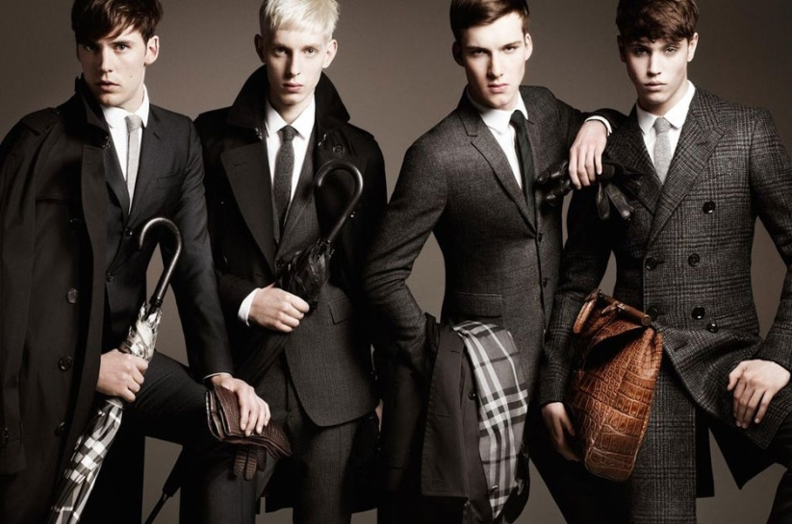

A lighter, more classical version of the masquerade theme.

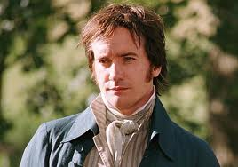
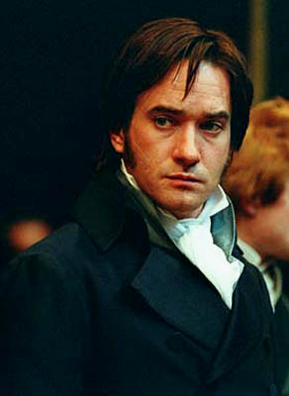
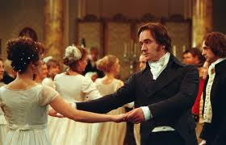
Royal ball theme 1800’s:

A darker-romantic theme. Dark shades of blue, red, grey, black are most common.

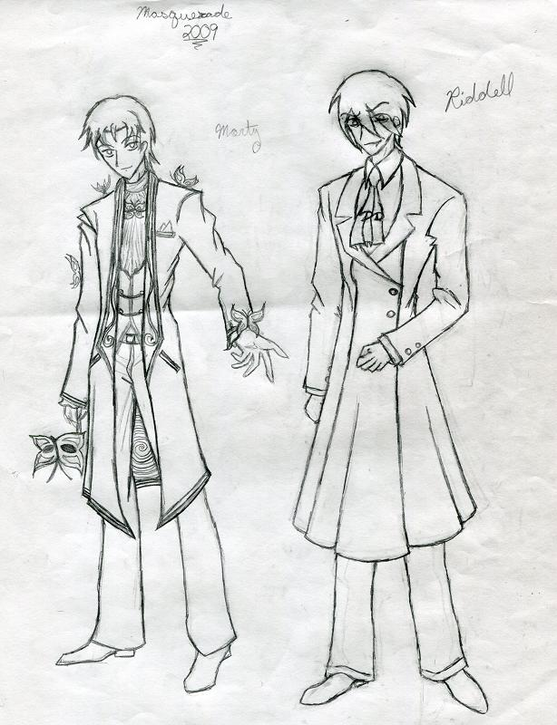

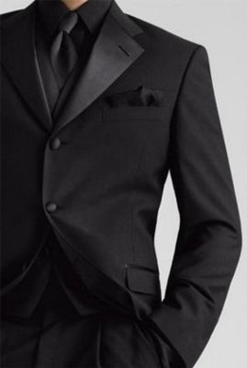
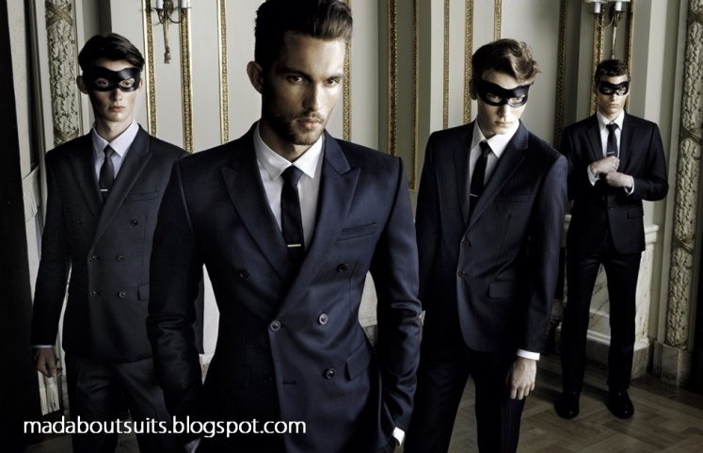
Masquerade theme(Now/1800’s):

